DATA STRUCTURE AND ALGORITHM
Name: Lorenzo M. Bautista Prof: Ma’am Gloria Dela Cruz
Section: BSIT 104 Date: March 25, 2026

LABORATORY 3
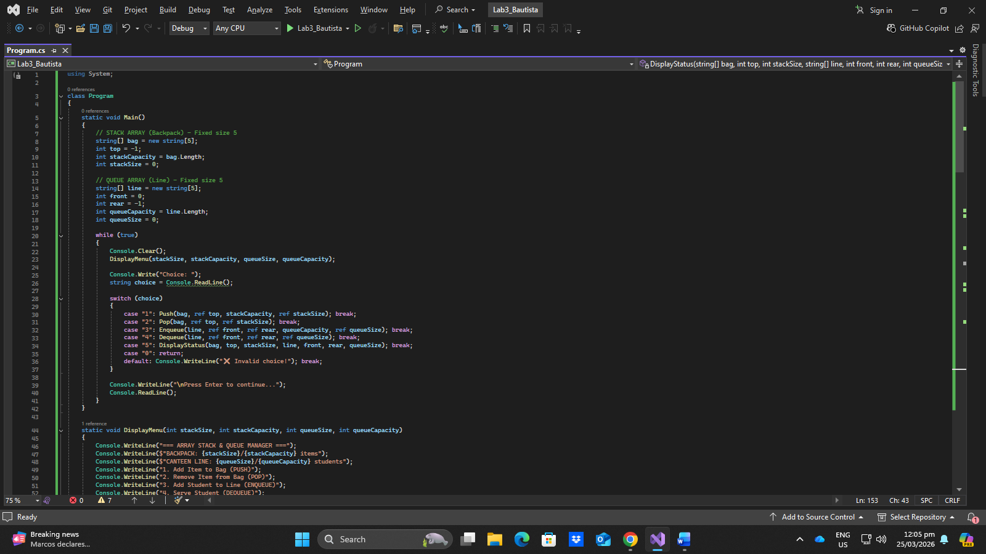
Code:

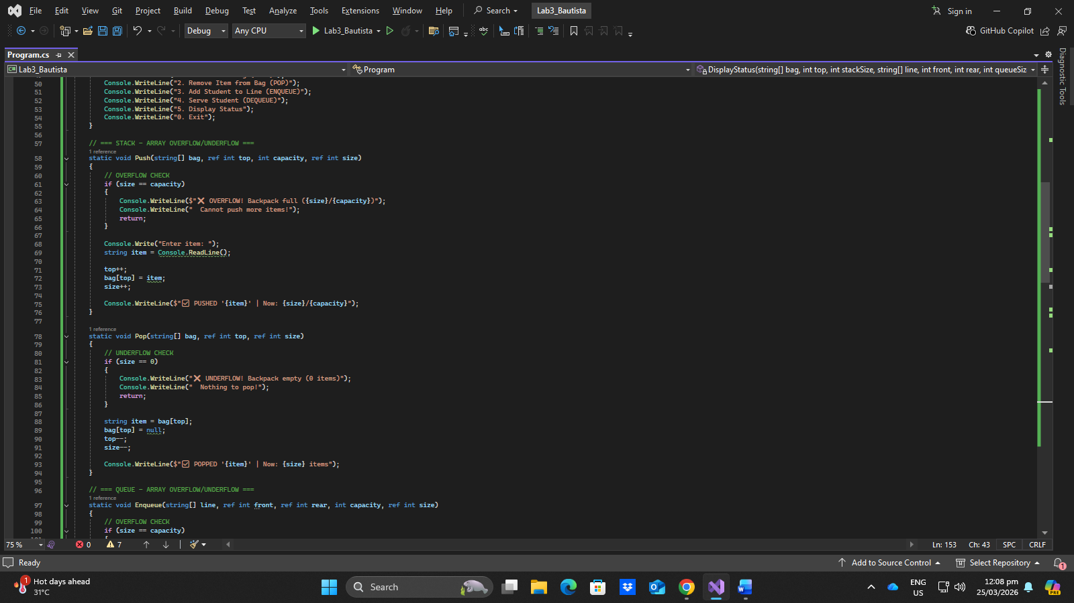

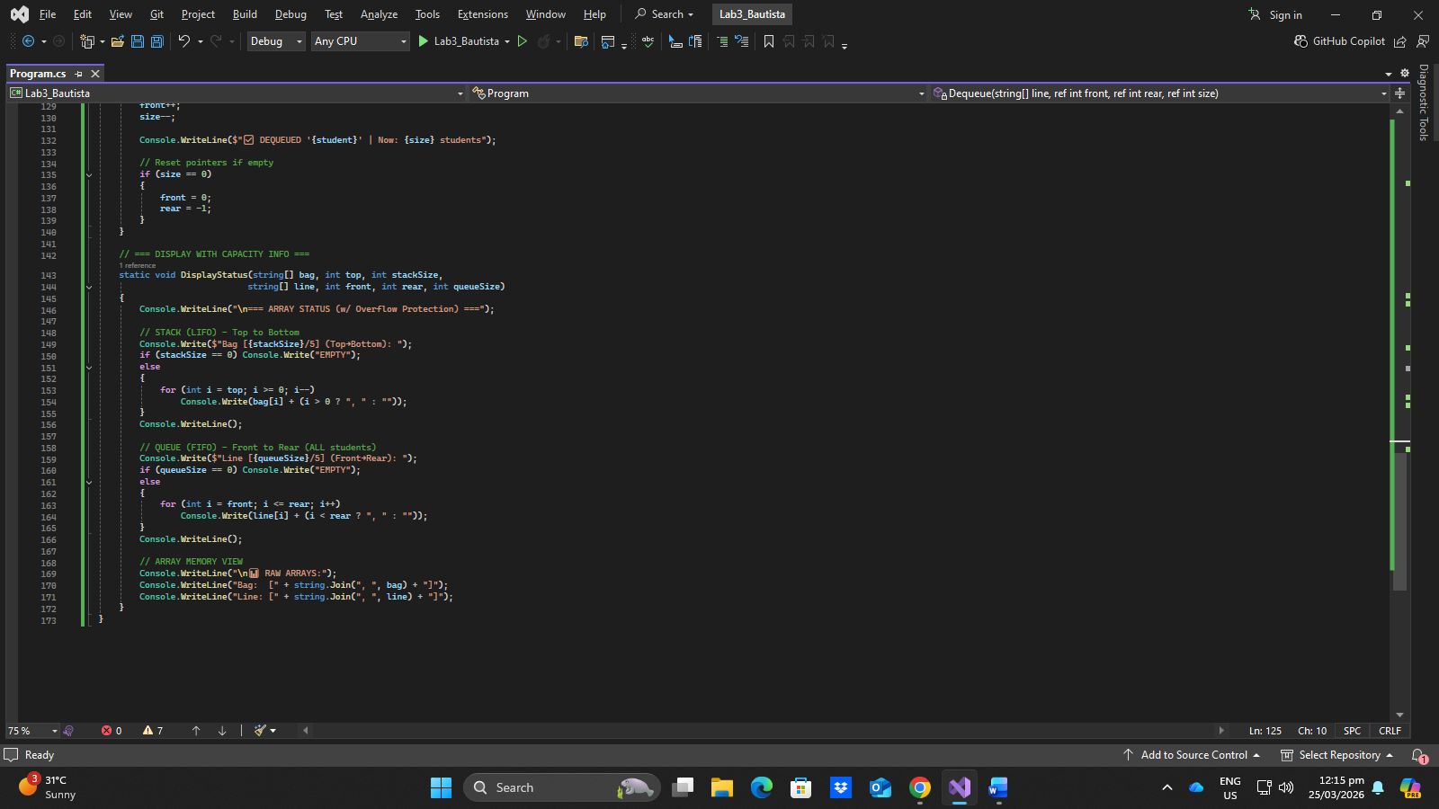
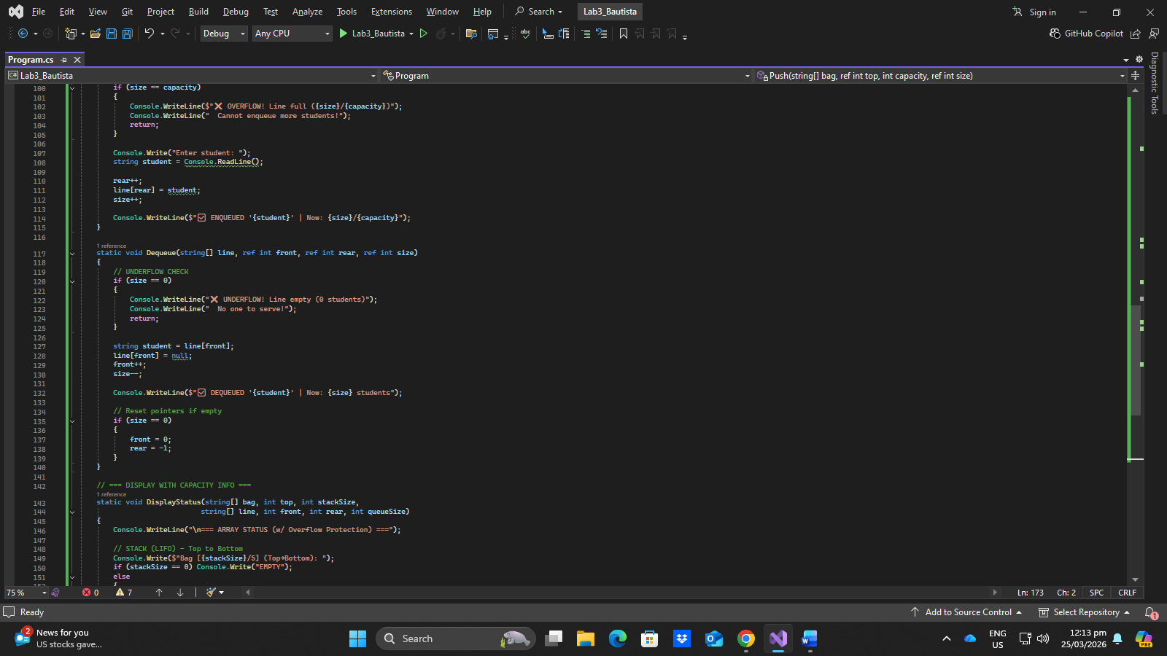

Output:
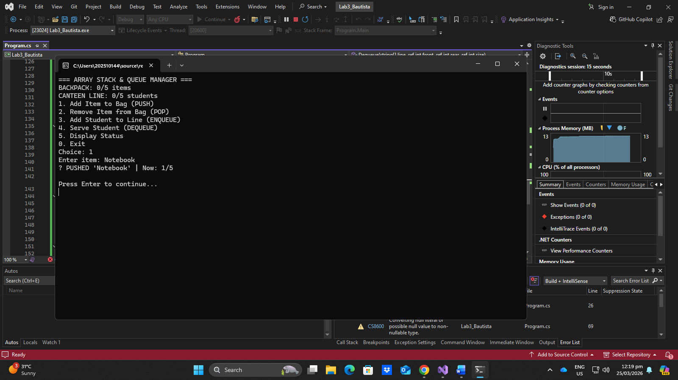
PUSH ITEM
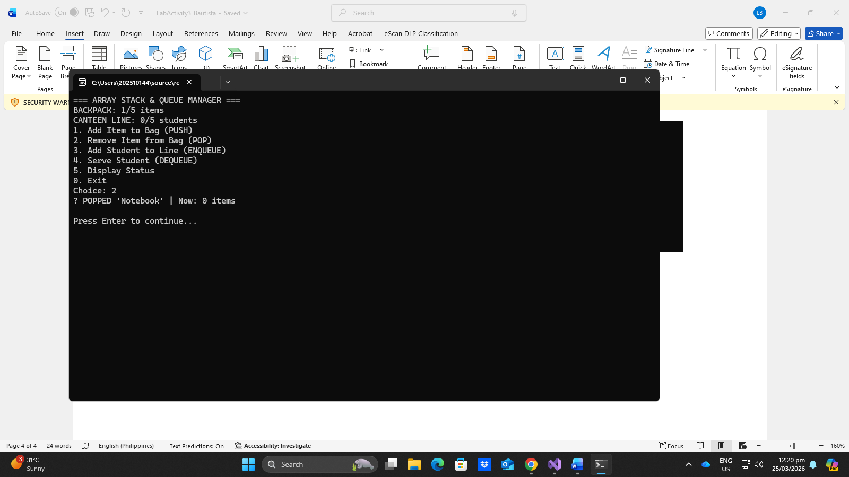
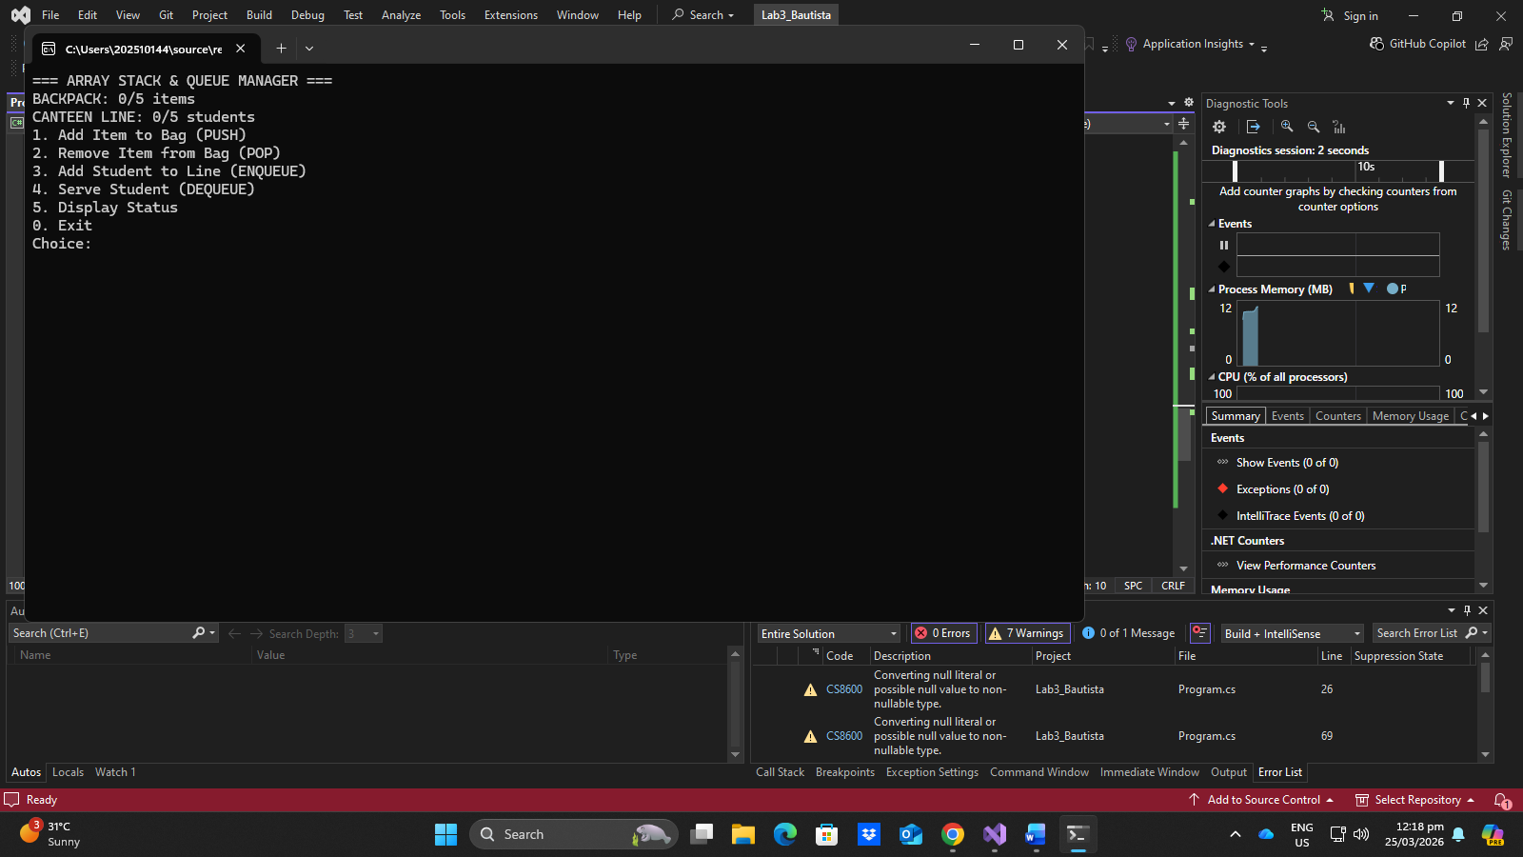
POP ITEM
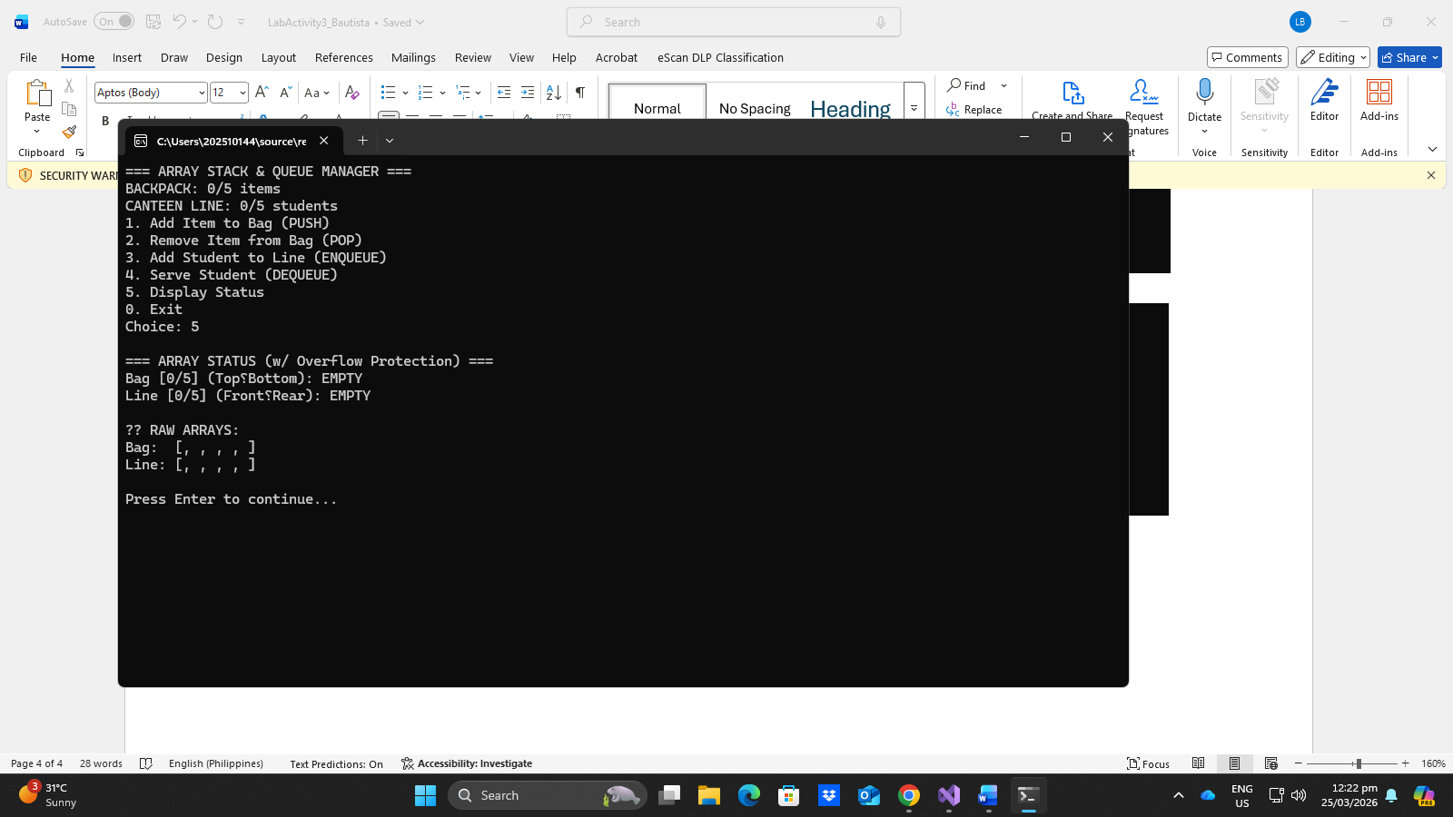
DISPLAY ALL ITEMS

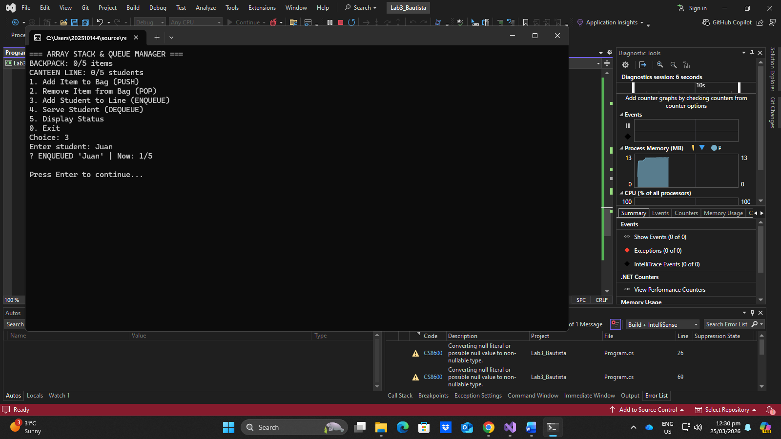
ADD STUDENT
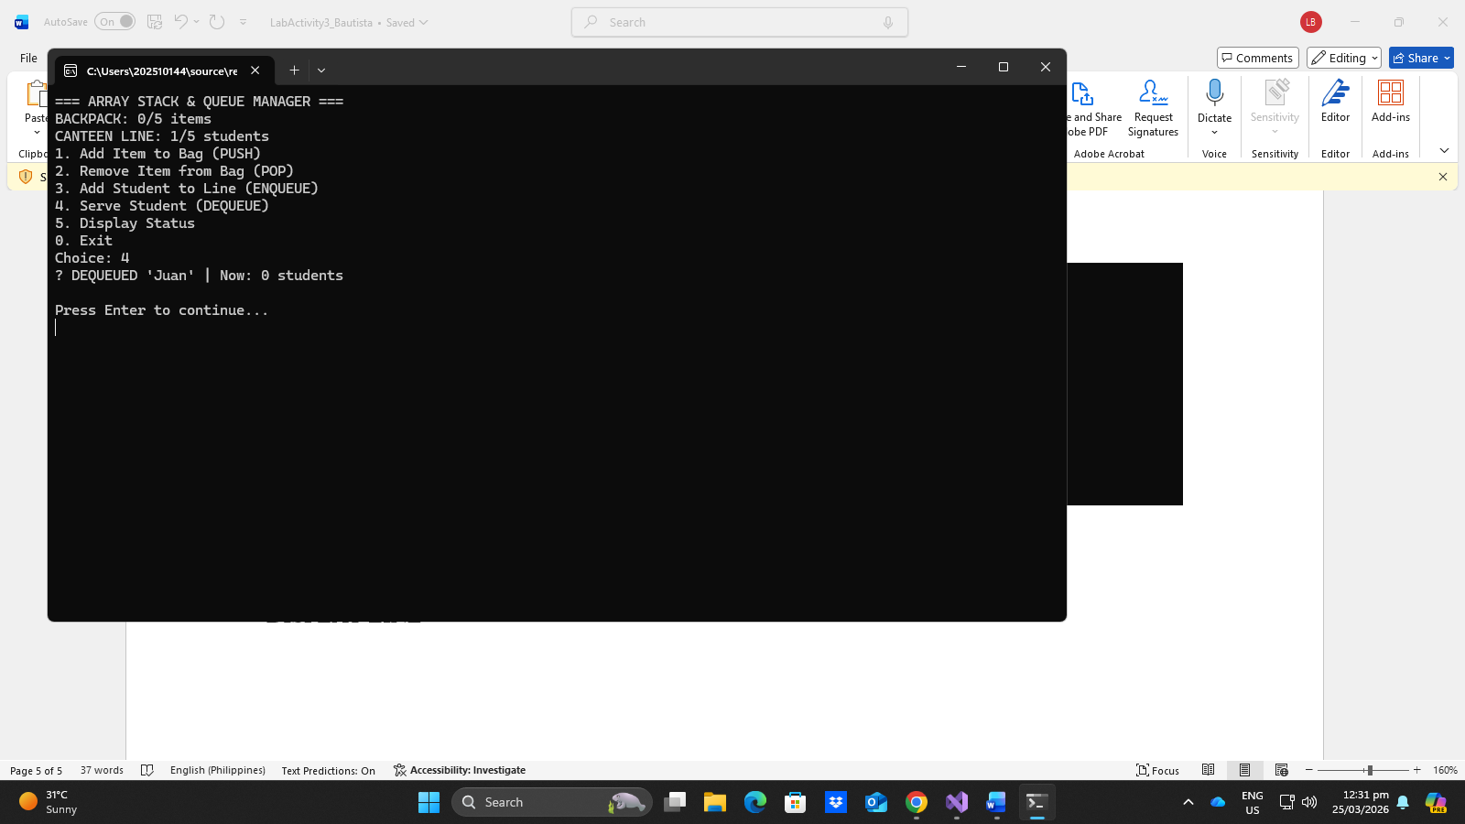
SERVE STUDENT

DISPLAY LINE

QUESTIONS
STACK
- Why is it called LIFO?
It is called LIFO because the last item placed inside the stack will be the first one out of the stack.
- What happens when top = -1?
When the top = -1 it means that the stack is empty.
- After 3 pushes, what is the value of top?
After 3 pushes the stack will have 3 items inside of it.

QUEUE
- Why do we need both front and rear?
We need both front and rear to be able to add and remove people inside the queue.
- What happens when queue is full?
When the queue is full the user won’t be able to enqueue anymore because of overflow.
- Can front > rear?
If front > rear this means that the queue is empty.

